CRIMINAL IDENTIFICATION WITH FACE RECOGNITION

TABLE OF CONTENTS
LIST OF TABLES iii
LIST OF FIGURES iii
ABSTRACT iii
CHAPTER ONE 1
1. INTRODUCTION 1
1.1 Background of the organization 1
1.2 Objective of the Project 1
1.2.1 General Objective 1
1.2.2 Specific Objective 1
1.3 Scope and Limitation of the Project 2
1.3.1 Scope of the Project 2
1.3.2 Limitation of the Project 2
1.4 Methodology of the Project 3
1.4.1 Development Tools and Techniques 3
CHAPTER TWO 4
2. PROPOSED SYSTEM 4
2.1 Functional Requirement 4
2.2 Non-Functional Requirement 6
2.2.1 Hardware Consideration 6
2.2.2 Security Issues 6
2.2.3 Performance Consideration 6
2.2.4 Error Handling and Validation 6
2.2.5 Backup and Recovery 7
2.2.6 Physical Environment 7
2.2.7 Resource Issues 7
CHAPTER THREE 8
3. SYSTEM ANALYSIS 8
3.1 System Model 8
3.1.1 Use Case Model 8
3.2 Object Model 9
3.2.1 Class Diagram 9
3.2.2 Data Dictionary 11
CHAPTER FOUR 13
4. SYSTEM DESIGN 13
4.1 Design Goals 13
4.1.1 Performance Consideration 13
4.1.2 Dependability 13
4.1.3 Maintenance 13
4.1.4 End User 14
4.2 Proposed System Architecture 14
4.2.1 Hardware/Software Mapping 14
4.2.2 Detailed Class Diagram 16

LIST OF TABLES
Table 3-1: Use case of the system 8
Table 3-2: Data Dictionary for Criminal 11
Table 3-3: Data Dictionary for Login 11
Table 3-4: Data Dictionary for Message 11
Table 3-5: Data Dictionary for Employee 12
Table 3-6: Data Dictionary for Case 12

LIST OF FIGURES
Figure 3-1: Use case diagram of the system 9
Figure 3-2: Class diagram of the system 10
Figure 4-1: Deployment diagram Hardware/Software mapping 15
Figure 4-3: Detailed class diagram 16

ABSTRACT
This project, Criminal Identification System with Face Recognition, provides a scalable and efficient way of maintaining criminal information and supporting law enforcement agencies worldwide. Traditional manual systems are prone to redundancy, misplacement, and delays in retrieving records. Our system leverages modern web technologies — Django REST Framework for backend services, React with Bootstrap for frontend interfaces, and PostgreSQL for secure, scalable data storage. Facial recognition is implemented using OpenCV and deep learning models to generate embeddings that are matched against stored records. The system supports global deployment, enabling interoperability across jurisdictions, real-time alerts to authorized agencies, and secure access through JWT authentication. By adopting a three-tier architecture, the solution ensures performance, reliability, and extensibility, making it suitable for international law enforcement collaboration.

CHAPTER ONE

INTRODUCTION

Background of the organization
Face recognition is one of the most challenging topics in computer vision today. It has applications ranging from security and surveillance to entertainment websites. Face recognition software is useful in banks, airports, and other institutions for screening customers. This shows how this technology is applicable in multi-disciplinary fields of study.
Human face is a dynamic object having high degree of variability in its appearance, which makes face recognition a difficult problem in computer vision. In this field, accuracy and speed of identification is a main issue.
In face recognition, Image Processing plays an important role in day-to-day life of human beings. It is a multi-disciplinary field of study, which can be applied to agriculture, industrial processing, and security system and so on. Among the fields of study in image processing, face recognition plays vital roles in industrial security system analysis of crime (In the field of criminal investigation).
In this system the camera is fixed inside or outside room and it will capture the image; the faces are detected and then it is recognized with the database and finally the person is marked. If the person is marked as criminal, the message about the criminal is notify authorized law enforcement agencies in real time.

Objective of the Project

General Objective
To design and implement a global criminal identification system using face recognition technology, providing secure, scalable, and user-friendly access for law enforcement agencies worldwide.

Specific Objective
- To develop a module that stores and retrieves criminal information with facial embeddings.
- To implement face detection and recognition using OpenCV and deep learning models.
- To provide case scheduling with international calendar support.
- To implement and deploy a web-based application accessible globally.
- To ensure secure authentication and role-based access using JWT.
- To design a responsive user-friendly user interface with React and Bootstrap.
- To enable real-time notification and alerts for authorized agents.
- To support report generation and analytics for crime management.

Scope and Limitation of the Project

Scope of the Project
In general, the scope of our system is as follows:
- Maintain and store global criminal information.
- Provide centralized, scalable database records.
- Support cross-border identification of suspects.
- Enable integration with international law enforcement databases (e.g. Interpol)
- Provide secure roles for multiple roles (e.g. admin, officer, investigator)
- Generate reports and analytics for crime trends.

Limitation of the Project
As a part of image processing, face recognition is not a simple task, especially when a real time face recognition is implemented. It is because the natural difference in human faces, the problems on human faces and sensitivity of face recognition algorithms, this project is not supposed to perform the following tasks.
- The system may challenge to differentiate identical twins or heavily altered features.
- Accuracy may be decreased with poor lightening or occlusions (e.g. masks, hats)
- Global deployment requires compliance with international policy laws (GDRP, data sovereignty)
- Large scale databases may require advanced optimization and distributed storage.

Methodology of the Project

Development Tools and Techniques

Frontend Technologies
- React (UI framework)
- Tailwindcss (styling)
- React Icons (UI icons)
- Axios (API calls)

Backend Technologies
- Django REST Framework (API development)
- Face Recognition libraries (OpenCV, or deep learning models)
- JWT Authentication for secure access

Database Technologies
- PostgreSQL (scalable relational database)
- Optimized schema for criminal records, facial embeddings, and case logs

CHAPTER TWO

PROPOSED SYSTEM
Face recognition is an important project and research topic because of its application in different environment a disciplinary like the field of computing, psychology, and neurology for a different purpose. On the other hand, face recognition plays its own role in the field of security and different levels from identification to authentication for systems. Face recognition in the field of security and criminal investigation applies different techniques for analyzing and processing a face image. Here in this project, an analytical technique for face recognition is used for extracting feature components of a face for face identification.
Face recognition is the process of identifying a criminals based on their facial characteristics or based on their facial features. To identify the criminal system process through preprocessing and post-processing. In preprocessing system detect face, in face detection the system finds face (location and size) in an image, the face is detected by applying detection algorithm which is called HAAR classifier OpenCV (Open Computer Vision) library using camera, after the face is detected, the system captures the detected face.
In post-processing, the captured face is extracted using LBPH (Local Binary Pattern Histogram) algorithm and match the extracted face with the facial node stored in the database and identify the criminals and police officers, finally display the information of recognized face from database. This system is a new system that does not match with a current exist system, which stores criminal picture and all other management works in the manual format, and we develop a system that stores the captured criminal face and all other management works like generating report, criminal registration, and others in the database.

Functional Requirement
- Face Detection
- This involves finding all face regions in an image. This can be achieved by scanning the image at all possible locations and scales. Once these regions are found they are sent to the next module.
- This system shall detect the face of criminals as he/she enters in to the camera coverage area. This system uses HAAR Cascade Classifier OpenCV library for face detection. This algorithm used for finding the location of the human faces in a frame or image and gives the coordinate of x, y, w, h which makes a rectangle box in the picture to show the location of the face or we can say that to show the region of interest in the image. After this, it can make a rectangle box in the area of interest where it detects the face.
- Face Recognition
- Here all the face regions are processed so that the identity of the people is found. This system uses LBPH (Local Binary Pattern Histogram) algorithm for face recognition. It is simple and very efficient texture operator which labels the pixels of an image by thresholding the neighborhood of each pixel and considers the result as a binary number.
- Inserting Information
- Allows the police officers and system admins to insert police officers and criminal’s information with their face image (insertion of information like their ID, Name and others with face detection are taken place).
- Updating Information
- Allows the system admin to update criminals and police officer’s information and system controller to update image when its required.
- The system also should provide password changing facility.
- Manage User Account
- The system shall allow the system admin to manage user account such as create account
- Allow police officer to get alert when criminals are identified.
- Case registration using our automated system.
- Generating reports using our automated system.
- Case scheduling with international calendar support (ISO date/time standards).
All of the functions that are listed in the above are our functional requirement that our system must include it, so we are going to develop a system that easily controlled and managed by the user by including the above major functions.

Non-Functional Requirement

Hardware Consideration
- The system we are going to develop is system independent and it will interact with other hardware.
- The hardware that required after develop the system is basically the following.
CPU … 64-bit Core i3(TM) 3.30 GHz
RAM … Minimum of 2 GB
Hard Disk … Minimum of 40 GB and others
Camera … four cameras (pixel resolution is 1280 x 1024 and HD quality camera)

Security Issues
- Security requirement is important factor in this system as classified data (information will be stored in the database. User validation will be done during login to ensure that the user is valid and that the user only has access to his/her permitted information and we can add the security capabilities of SHA-256 hashing for password storage and JWT authentication for secure session management.

Performance Consideration
- The performance of this system is measured in terms of load time and response time. So, it is fast to capture face and displays the result to achieve this we will use the best algorithm and the police station must have a fast internet network (LAN) which helps to access the information of user from a database.
- We use three-tier architecture to speed up our system, because in three-tier the presentation tier can cache requests, network utilization is minimized, and the load is reduced on the application and data tiers. If needed, you can load-balance any tier.

Error Handling and Validation
- The system will check user inputs to the system to handle error (the system will allow the user to correct their error by showing their error in the form of message in the display). It handles and shows error by showing the message “You Insert Invalid Input” when user enters invalid inputs.

Backup and Recovery
- The proposed system can be damaged or fail if there is virus attack and continuous power disconnection from the source station and the data can be lost at that time. The system should be holding a backup of the data because database backup technology is available.

Physical Environment
- The system deployed is web-based application accessible globally. To protect the server and camera from overheat and other natural disasters like rain, high wind pressure, we should have to keep away from and keep ventilated condition for better protection.

Resource Issues
- Server:
- CPU: 32-bit or 64-bit Core i3(TM) 3.3 GHz
- RAM: 2 GB or higher is recommended
- Client:
  - The client is required for accessing the service provided by the server
- Camera:
- The camera is required for capturing criminal face and retrieve face image for client.
- The Camera might require.
- High resolution camera
- HD quality camera

CHAPTER THREE

SYSTEM ANALYSIS

System Model

Use Case Model
Actors can be a human user, some internal applications, or may be some external applications. When we planning to draw a use case diagram, we should have the following items identified.
- Functionalities to be represented as use case.
- Actors and Relationships among the use cases and actors.

Use Case
The following use cases have been identified from the system specification:
Table 3-1: Use case of the system
Detect Face | Update Account
Upload image | Send Message
Capture Face | View Message
Create Account | Block Criminal Information
Display alert | Add Criminal Information
Control camera | Search Criminal Information
Login | Update Criminal Information
Logout | Store Data
Generate Report | Register Case
Delete Account

Actors
In this system the identified actors that will be participating in the system are:
- Administrator
- Detective / Officer
- System (external services, e.g., Interpol API)
System Use Case diagram for Criminal Identification with Face Recognition
Figure 3-1: Use case diagram of the system

Object Model

Class Diagram
Class diagram is a static diagram. It represents the static view of an application. Class diagram is not only used for visualizing, describing, and documenting different aspects of a system but also constructing executable code of the software application. This class diagram also describes the attributes and operations of a class and also the constraints imposed in the system.
The class diagram is widely used in the modeling of object-oriented systems because they are the only UML diagrams, which can be mapped directly with object-oriented languages. We are developing object-oriented base system, so we are going to use class diagram to model the static view of our system.
Figure 3-2: Class diagram of the system

Data Dictionary

Data Dictionary for Criminal
Table 3-2: Data Dictionary for Criminal
Number | Column Name | Data Type | Constraint
1 | IDNumber | Int (15) | Primary key
2 | FirstName | VARCHAR (20) | Not NULL
3 | MiddleName | VARCHAR (20) | Not NULL
4 | LastName | VARCHAR (20) | Not NULL
5 | DOB | Date (12) | Not NULL
6 | Age | Int (3) | Not NULL
7 | Gender | VARCHAR (6) | Not NULL
8 | Nationality | VARCHAR (20) | Not NULL
9 | EducationLevel | VARCHAR (15) | Not NULL
10 | CrimeType | VARCHAR (30) | Not NULL
11 | Religion | VARCHAR (15) | Not NULL
12 | Status | VARCHAR (15) | Not NULL
13 | RandomID | Int (12) | Unique Key
14 | Image | BYTEA | Not NULL

Data Dictionary for Login
Table 3-3: Data Dictionary for Login
Number | Column Name | Data Type | Constraint
1 | IDNumber | Int (5) | Auto Increment
2 | FirstName | VARCHAR (20) | Not NULL
3 | MiddleName | VARCHAR (20) | Not NULL
4 | Image | BYTEA | Not NULL
5 | Username | VARCHAR (25) | Primary Key
6 | Password | VARCHAR (18) | Not NULL
7 | Position | VARCHAR (15) | Not NULL

Data Dictionary for Message
Table 3-4: Data Dictionary for Message
Number | Column Name | Data Type | Constraint
1 | MessageNum | Int(8) | Auto Increment
2 | Title | VARCHAR(30) | Not NULL
3 | Sender | Int(12) | Not NULL
4 | Receiver | Int(12) | Not NULL
5 | Date | Date(12) | Not NULL
6 | Message | VARCHAR(500) | Not NULL

Data Dictionary for Detective Police
Table 3-5: Data Dictionary for Employee
Number | Column Name | Data Type | Constraint
1 | IDNumber | VARCHAR (15) | Primary Key
2 | FirstName | VARCHAR (20) | Not NULL
3 | MiddleName | VARCHAR (20) | Not NULL
4 | LastName | VARCHAR (20) | Not NULL
5 | DOB | Date (12) | Not NULL
6 | Age | Int (3) | Not NULL
7 | Sex | VARCHAR (6) | Not NULL
8 | Role | VARCHAR (15) | Not NULL
9 | RandomID | Int (12) | Unique Key
10 | Image | BYTEA | Not NULL

Data Dictionary for Case
Table 3-6: Data Dictionary for Case
Number | Column Name | Data Type | Constraint
1 | RandomID | Int (12) | Primary Key
2 | CaseName | VARCHAR (20) | Not NULL
3 | CaseType | VARCHAR (30) | Not NULL
4 | AttackedBy | Int (15) | Not NULL
5 | AttackedTo | Int (15) | Not NULL
6 | AddedDate | Date (12) | Not NULL

CHAPTER FOUR

SYSTEM DESIGN
I have identified the functional and non-functional requirement of the system and produced analysis model in the previous chapter. In this chapter we will discuss the design goal, System architecture, System decomposition, deployment, and other design considerations.
This project is designed to solve the challenges of criminal identification and case management on a global scale, minimizing manual workload, improving accuracy, and enabling real-time collaboration between law enforcement agencies worldwide.

Design Goals

Performance Consideration
The system is designed for high performance, ensuring fast response time, and scalability.
- Load Time: Information should load within seconds, even with large datasets.
- Throughput: The system supports multiple concurrent users and simultaneous camera feeds.
- Response Time: Notifications and alerts are delivered in real time to authorized agencies.
- Scalability: Cloud deployment allows horizontal scaling to handle millions of records.

Dependability
This system must be available, secure, and reliable:
- Availability: - Operates 24/7 with minimal downtime, supported by cloud infrastructure.
- Security: - Role-based access control, JWT authentication, and encrypted data storage.
- Reliability: - Ensures accurate recognition results and consistent system behavior.

Maintenance
The system is modular, making it easy to extend and modify:
- Extensibility: - New features can be added without disrupting existing modules.
- Modifiability: - Updates to one component do not affect the overall system.
- Maintainability: - Clear separation of concerns between frontend, backend, and database.

End User
The user interface prevents errors and ensures usability:
- Responsive design for desktop and mobile.
- Clear error messages and guided workflows.
- Prevents invalid commands or incorrect data entry.

Proposed System Architecture
The system follows a three-tier web architecture:
- Presentation Layer (Frontend):
- Built with React, Bootstrap, and React Icons.
- Provides dashboards, case management views, and facial recognition results.
- Communicates with backend via RESTful APIs.
- Business Logic Layer (Backend):
- Implemented with Django REST Framework.
- Handles authentication, facial recognition processing, and case management logic.
- Integrates with OpenCV and deep learning models for face detection and recognition.
- Data Layer (Database):
- PostgreSQL stores criminal records, facial embeddings, case logs, and user accounts.
- Optimized schema supports large-scale queries and secure storage.
- Backup and recovery mechanisms ensure data integrity.

Hardware/Software Mapping
- Client Side (Browser):
- Runs the React-based user interface.
- Displays dashboards, alerts, and case management tools.
- Application Server:
- Hosts Django REST Framework.
- Processes recognition requests and manages business logic.
- Database Server:
- PostgreSQL stores structured records and embeddings.
- Supports distributed storage for global scalability.
- Camera Devices:
- High-resolution cameras capture facial images.
- Streams are processed by the backend recognition module.
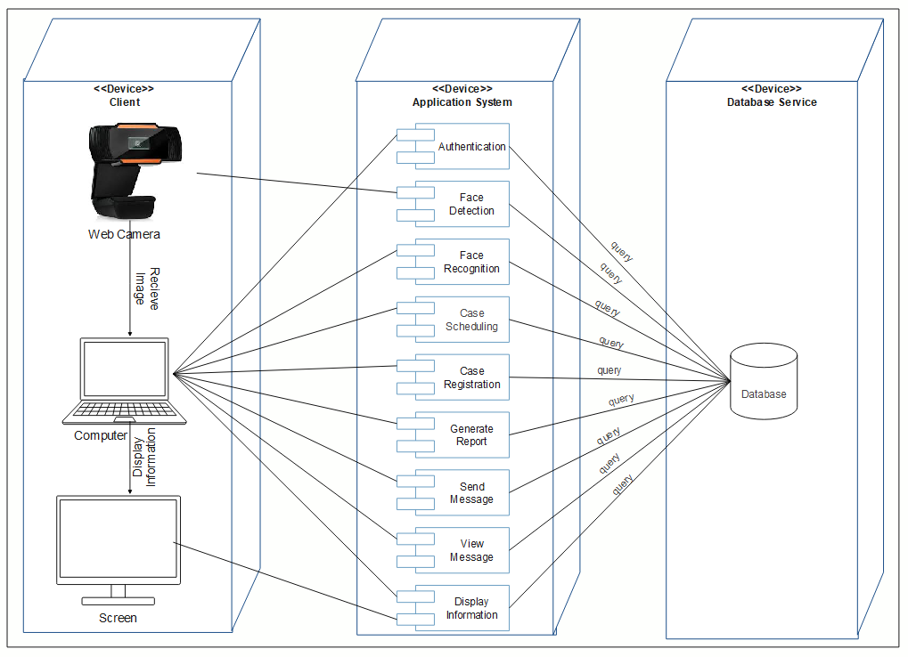
Figure 4-1: Deployment diagram Hardware/Software mapping

Detailed Class Diagram
Figure 4-3: Detailed class diagram

